Local Admin Password Solution – Kforce International Tenant (India)
This guide explains how to access and rotate the local administrator account name and password for Kforce international teant. Each laptop has a unique local admin account name and password.
Local Admin Account Name: .\Gatekeeper(%random%)
Local Admin Password: random
Get Local Admin Account Name & Password
- Log in to Kforce International Intune portal.
- Find the device and select it.
- Click the Local Admin Password tab in the device profile.
- Select 'Show local administrator password' to view Local Administrator Account Name and password.
- Use the password for elevated access.
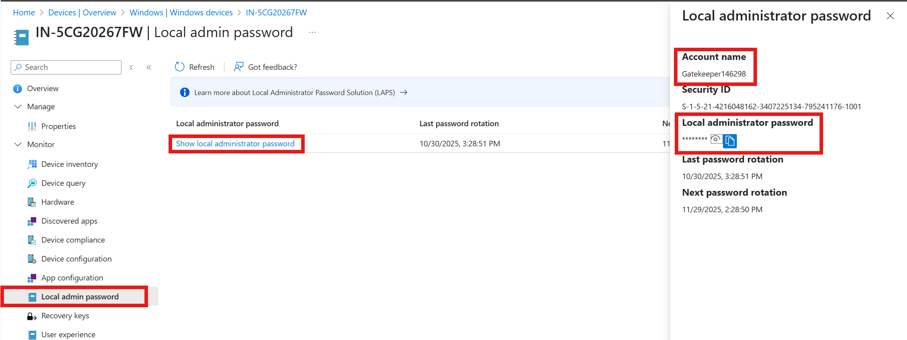
Rotate Local Admin Password
- In Intune, open the Overview tab of the device profile.
- Choose 'Rotate local admin password' from the ribbon.
- Confirm by selecting Yes.
